**Creating Progress Bar in Figma**

**-Pratham Shah**

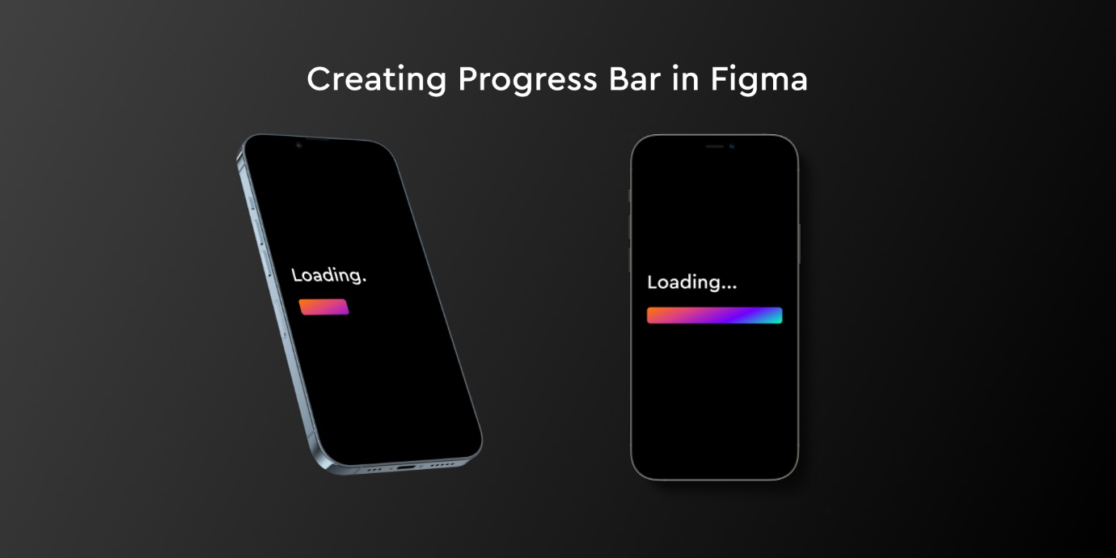

**Link of the prototype:** https://www.figma.com/proto/LzxX7CRID2GjkQNpDCzmPl/Progress-Bar?page-id=0%3A1&node-id=2%3A24&viewport=241%2C48%2C0.12&scaling=scale-down&starting-point-node-id=1%3A2

* Progress bar or loading bar can be made easily in Figma using the smart animate interaction prototyping option.
* First, I created a rectangle with some gradient in it (this is optional).
* Followed by which, I created a frame of very small length in which I put the rectangle and placed it in the main phone frame.
* Then I made a duplicate of the main phone frame and in this, I increased the size of the loading bar frame.
* I kept making duplicates and progressively kept increasing the size of the bar till it was of full length.
* I then applied the prototyping interaction between the consecutive frames using “delay” and smart animate. The time for each interaction depends on the designer. I kept each of them as 1200ms for a sufficient

time duration.

**Screenshots:**

